NORTH DAKOTA WINTER SHOW
ENTRY FORM/RELEASE OF LIABILITY
2019 MUTTON BUSTING COMPETITION
March 7th ~ 6:30 pm

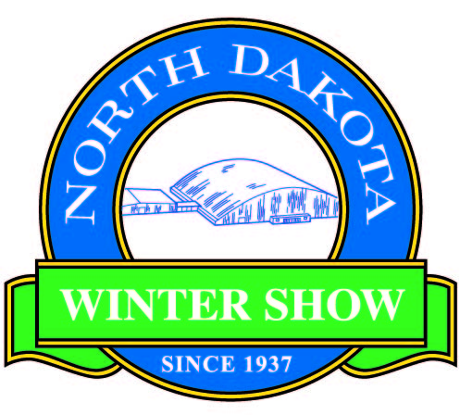

General Information/Requirements:
- Mutton Busting will also be held during our Ranch Rodeo performance at the North Dakota Winter Show, scheduled for Thursday, March 7th, 2019 at 6:30 pm.
- To enter, kids must be ages 4-7 and weigh 55 pounds or less. A protective vest and helmet will be provided.
- No entry fee is required, but tickets must be purchased for the respective rodeo performance. Tickets for admission into the Rodeo are $12; and $7 for ages 12 and under. Prizes will be awarded to the first place contestants in each competition.
- The mutton busting competition will be limited to only 8 contestants, so get your forms in early!
Contestant: Name______________________________________________ Birthdate______________________
Parent(s): Name(s)______________________________________________Phone #_______________________
City/State_______________________________Email________________________________________________
Shirt Size (Youth) S M L ______________________
Information for announcer: (parents, # of contests entered, etc.)________________________________________
____________________________________________________________________________________________
Release of Liability: I, the parent or guardian of the child listed above, hereby release and discharge the North Dakota Winter Show, its officers and volunteers (hereinafter referred to as the committee), contractor Aaron Henderson and contractor Bailey Pro Rodeo, their subsidiaries and related companies, agents, employees, and officers, from all claims, demands, and actions, both present and future, and all personal injuries arising out of the mutton busting competition, held at the North Dakota Winter Show during the Ranch Rodeo March 7, 2019.
I acknowledge the inherent risks involved in livestock activities, including, but not limited to, the propensity of livestock to behave in ways that may result in death or injury to persons on or around them, such as kicking, biting or bucking, the unpredictability of livestock’s reaction to things like sound, sudden movement, unfamiliar objects, persons or other animals, natural hazards such as surface or subsurface conditions, or collisions with other livestock or objects.

I accept responsibility for the inherent risks involved in livestock activities and “mutton busting”, including the likelihood of serious injury and death. I have read this release and understand all of its terms and accept this as adequate notice. I certify that my child is physically capable of withstanding the rigors and demands of the mutton busting competition. I voluntarily sign this release with full knowledge that I will not be able to commence an action or suit in any forum against or hold the committee, contractors, or Bailey Pro Rodeo liable for such injuries.

Signature of parent or legal guardian_______________________________________Date_____________________
Return this form to the NDWS ~ 700 7th St. SE or by mail to PO Box 846 ~ Valley City, ND 58072

For more information, or to purchase rodeo tickets, contact the NDWS,
at 701-845-1401, 800-437-0218, or email ndws@northdakotawintershow.com.

